To: John Smith Head Training, U.S bicycle Team

From: Thomas Hansen, Sport Research Scientist, Alpha Lab

Date: December 29, 2022

Subject: Effect of the consumption of chocolate on cycling performance

***Background***

In our recently meeting, John mentioned a research study[1] on the effects of chocolate consumption versus cycling performance. As a follow-up action, our research team is tasked to investigate the research study in detail and present our findings. It is agreed that the focus is on the relationship between chocolate consumption with all-out bicycle sprint performance. All-out bicycle sprint performance, which measured the distance traveled in meters for a two-minute time trial, is one of the key measures in the study.

***Summary on Research Methodology***

In the research study, the experimental setup consisted of a randomized crossover design where 9 male riders’ all-out bicycle sprint was measured in two trials after participants consumed either dark chocolate (40 grams of Dove) or white chocolate (40 grams of Milkybar), each for two weeks. In this crossover design, the 9 male riders switched trial groups during the different two-week time periods so that they act as their own controls. Such reduces the variability in outcome measures from external environment.

In addition, nature of the sport only allows low number of qualified participants. By using crossover study, it enables same level of statistical power and precision as a parallel design, which would otherwise require 18 male riders.

***Research Findings***

Research indicates that

* Dark chocolate positively influences all-out bicycle sprint performance.
* While chocolate does not significantly influence all-out bicycle sprint performance

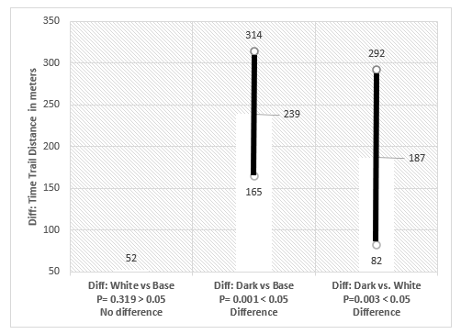

Chart Reference: Null Hypothesis

(Left P = 0.319) Diff: White vs. Base

There is no difference on performance between consuming and NOT consuming white chocolate.

(Center P = 0.001) Diff: Dark vs. Base

There is no difference on performance between consuming and NOT consuming dark chocolate.

(Right P = 0.003) Diff: White vs. Base:

There is no difference on performance between consuming dark chocolate and white chocolate.

Statistic Explanation

1.    Sample mean sprint meters increases by 239m (dark chocolate) and 52m (while chocolate) from baseline, respectively.

2.    Basis P value, there is strong evidence to support effect of dark chocolate on sprint performance (P= 0.001), while not sufficient to support effect of white chocolate on sprint performance (P= 0.319)

3.    Side comparison Dark vs While also support above statement (diff in mean = 187, P = 0.003)

***Recommendation***

The research study is published through credible journal. Statistic summary and research methodology is viable. We can therefore recommend the rider to consume dark chocolate as a performance booster in preparation for Tour De France. This is also a proven finding in the research. The use of dark chocolate has to respect individual rider's diet restriction and health concerns.

We also recommend continuing monitor rider's performance post chocolate consumption following similar research methodology, with the possibility to study alteration on cocoa % in dark chocolate. This could further enhance understanding on this topic and improve precision on adoption.

1. Patel, R. K.; Brouner, J.; Spendiff, O. Journal of the International Society of Sports Nutrition. **2015** 12:47.